Amazing Ecuador: Amazon Rainforest
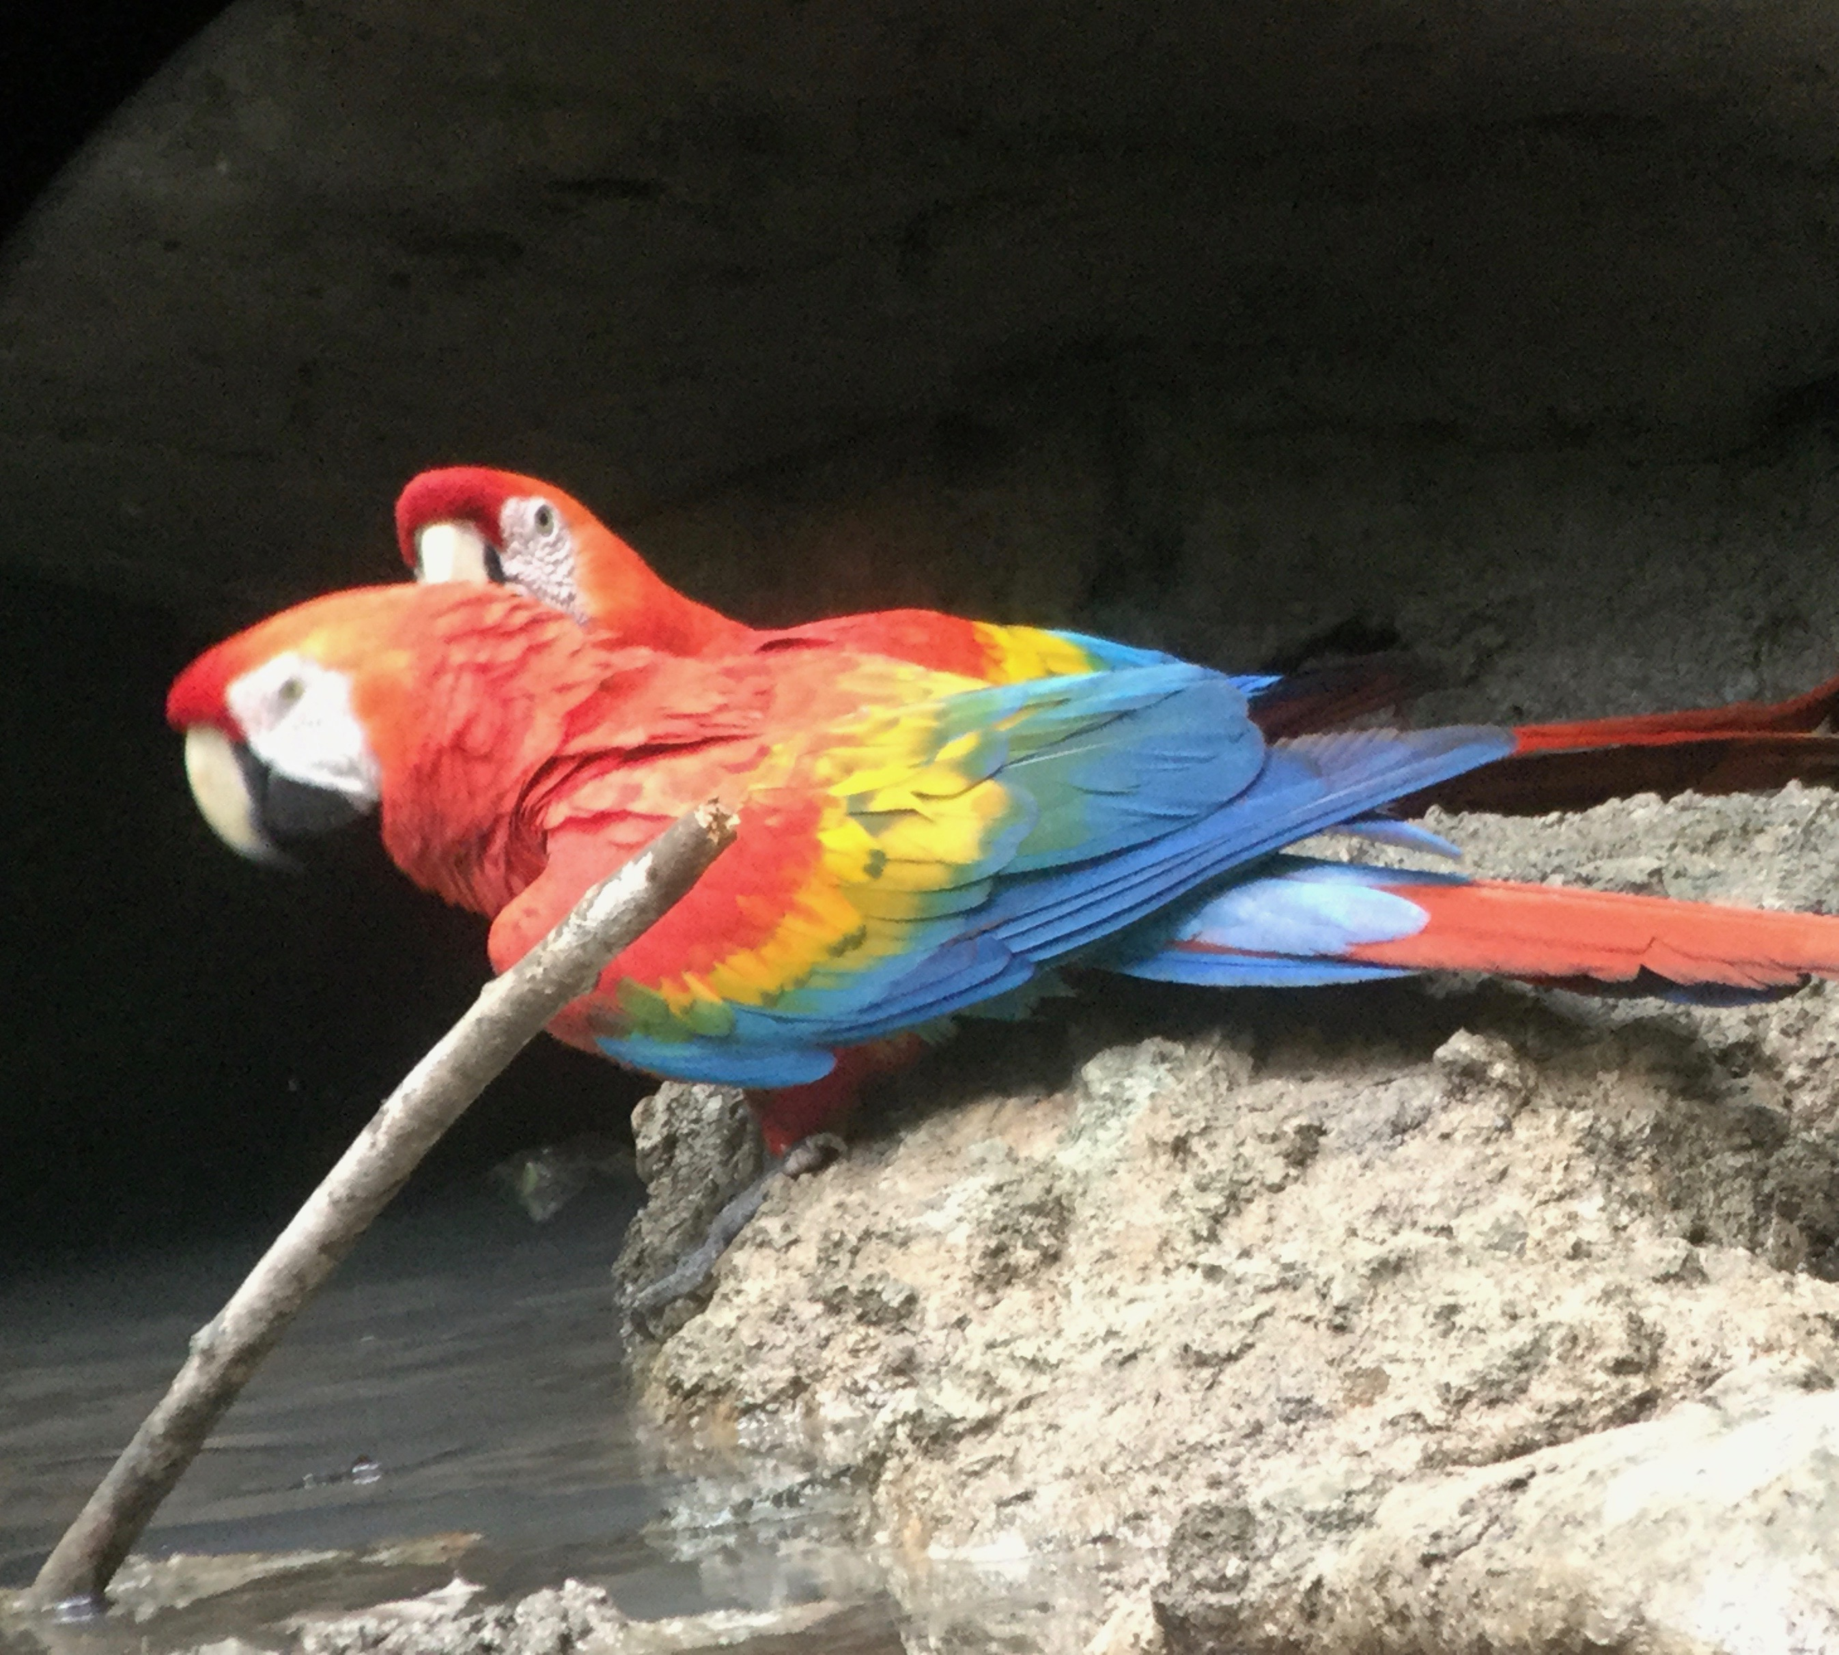

& Andes Escorted Trip
September 9 – 18, 2022
Cultural Adventures: Tours for the Young-at-Heart

Cultural Adventures tours offer you the opportunity to learn about both the Andes and Amazon Rainforest as part of a small group. You’ll enjoy select experiences away from the usual tourist sights during a visit that combines soft adventure with maximum comfort. Not only will you experience two diverse ecosystems of Ecuador, but you will also meet local people and learn about the culture. When you take a Cultural Adventures trip you are supporting local people who provide information and services.

- Designed for travelers who want an active trip in two very diverse ecosystems: The Amazon Rainforest and the Andes Mountains
- Escorted by Connie who will smooth out any bumps & provide useful travel tips before & during the trip
- Group size is limited to 10 or less

Highlights:

- Explore the Amazon Rainforest for five days while staying at a comfortable eco-lodge
- Climb a canopy tower for a close look at colorful tanagers, macaws, toucans, flycatchers and even Howler Monkeys feeding themselves on the nearby trees.
- Visit the Condor Park and indigenous market in the Andes town of Otavalo
- Experience the large animal & crafts market in the Andes

Trip Fee: $2895 per double occupancy -single supplement available or I can try and match you with a roommate
Included: All hotels, local flights, motorized canoe to the jungle, land transportation, tours, airport transfers, escort, guides & 21 meals.
Not included: International flight to Ecuador, tips, and personal expenses.

Itinerary:

Sept 9 – Arrive Quito on your own. You’ll be met at the airport and escorted to our hotel near the airport. Hotel Mariscal Sucre or equivalent
Sept 10, 11, 12, 13 - Amazon Rainforest – Our visit to the rainforest begins today. Traveling to our comfortable eco-lodge is an adventure. First, we take a short flight from Quito to Coca where we hop on a motorized longboat for a ride through the jungle. The Yasuní National Park is one of the most biologically diverse regions in the world. Daily activities are based on interest and will include hiking in the jungle, canoe rides, a visit to an indigenous family, canopy tower visits, relaxing in a hammock and kayaking. In the evening you might canoe the river or walk to view nocturnal rainforest animals such as caiman, monkeys, insects, and owls. Napo Cultural Center Eco-Lodge (B, L, D)

Sept 14 - Quito – We’ll return from the rainforest and be met by our private guide Angel. We’ll take the Teleferiqo cable car , 14,000 feet to the top of Cruz Loma, for a marvelous view of Quito. After checking in at the hotel the evening is free for you to relax or explore the city.. (B, L)

Sept 15 – Quito – Today you’ll have an introduction to Quito, a cosmopolitan and historic capital city, located in the majestic Andes Mountains. We’ll begin by exploring Quito's colonial quarter, the largest and best preserved in South America and a UNESCO World Heritage Site. After lunch you’ll discover the fascinating work of one of the most renowned artists of the country, Oswaldo Guayasamín at the Chapel of Man Museum (B, L)

Sept 16 – Otavalo – Condor Park - We’ll take a private van and drive north through amazing Andean landscapes to Otavalo with its famous indigenous market featuring an amazing array of textiles and crafts. Lunch at the historic Hacienda Pinsaqui will feature local dishes. Next is a visit the Condor Park designed to protect, rescue, rehabilitate and reintroduce the Andean Condor and other birds of prey to their original habitat. (B, L)

Sept 17 Otavalo -Indigenous Market - The morning begins with a stroll through the famous Otavalo handicraft market. Local artists and those from the countryside setup their displays. Here you’ll see a wide variety of woven textiles made into blankets, clothing, wall hangings, purses and fajas (woven belts). Interesting locally made jewelry and pottery is also available. At the huge food market Angel, our guide, will take you on a tasting tour of the market so you can try local specialties. The day ends with a visit to the workshop of local musicians who will introduce you to local instruments and music. (B,L)

Sept 18 – Middle of the Earth – Fly home . On the way to the Quito airport, we’ll stop at the Mitad Del Mundo and stand on both sides of the equator. The trip ends at the Quito Airport. (B)

Participant’s Background Information:

- US citizens do not need a visa to visit Ecuador.
- All travelers will need a valid COVID vaccination card showing that they have received a complete series of the COVID -19 vaccine
- The currency of Ecuador is the US dollar so there is no need to change money.
- This is an active adventure. Because of the heat and humidity, an Amazon jungle tour requires a reasonable level of fitness. Participants must be in good health, mobile and able to participate in 2-4 hours of physical activity daily.
- Basic travel insurance with medical evacuation coverage is mandatory; insurance to cover trip cancellation is highly recommended.
- Deposit of $750 will reserve your spot. Cost of trip is $2895 per double occupancy, sgl supplement $420. Cultural Adventures alumnae receive a $100 discount. Balance due by July 21, 2022.
- Refunds, less $75, will be returned upon written request until July 1, 2022. After this date, no refunds of any type will be made.

Reserve your place today.
For more information go to www.culturaladventures.info or contact Connie Champlin at (317) 908-1220 - cchamp@culturaladventures.info

